Sentinel Automatic Antenna Tracker

LITE

ASSEMBLY MANUAL

VirtualPilot

NOTICE

The information contained in this document is believed to be accurate in all respects but is not warranted. The information is subject to change without notice and should not be construed in any way as a commitment by the manufacturer, supplier, distributor, affiliates or subsidiaries.

The manufacturer, supplier, distributor, affiliates or subsidiaries assume no responsibility or liabilities for any errors or omissions in this document.

Revisions of this document or new editions of it may be issued to incorporate such changes.

No part of this document can be reproduced or transmitted in any form or by any means without written permission from the manufacturer.

This device is a hobby grade device intended for use by hobbyists. It is not intended or warranted for commercial or military use.

This device must only be used in compliance with applicable legislation.

This use of device can be impacted by ferromagnetic / electromagnetic and GPS interference.

**Trademarks**

Other product names mentioned in this document may be trademarks of their respective companies and are hereby acknowledged.

© Copyright 2021, VirtualPilot  
All rights reserved

Table of Contents

AAT – DIY PCB assembly 4

AAT – DIY PCB connections – V1 rev F PCB 6

AAT – DIY PCB connections – V1 rev E PCB 7

AAT – DIY PCB connections – V1 rev D PCB 8

AAT – 3D STL and source files 9

AAT – 3D print recommendations 9

AAT – 3D printed component preparation 9

AAT – DIY Case assembly 10

AAT – Assembled unit 12

AAT – internal views 13

Parts list – STL components 14

Parts list – optional AAT STL extras 17

Parts list – miscellaneous STL 19

Parts list – fixings 20

Parts list – components 20

Parts list – extras 21

Video RX connections 22

PCB versions 23

Document revisions 23

# AAT – DIY PCB assembly

Solder the following parts to the PCB:

1. **RCA/Phone/CINCH video connector**
2. **4 pole video Fatshark style connector**
3. **DC Power connectors * 2**
4. **Buzzer (NOTE POLARITY)**
5. **LED’s * 4 - use 3d printed assembly jig to help (NOTE POLARITY below)**
6. **0.1” PCB header pins for strip on the following:**
   1. **W-EN (2 pins * 1)**
   2. **Servo (3 pins * 2)**
   3. **VRX-IN (5 pins *1)**
7. **IMPORTANT: Short or jumper pins “TR” (next to LED) (V1 – Rev E boards only)**
8. **IMPORTANT: Short or jumper pins “W-EN” (all boards)**

OPTIONAL – typically not used (extra PCB header pins required):

1. **OPTIONAL 0.1” PCB header pins for strip on the following:**
   1. **VRX-OUT (4 pins *1)**
   2. **I2C (4 pins *2)**
   3. **ISP (3 pins * 2)**
   4. **FTDI (6 pins * 1)**
   5. **W-FTDI (5 pins * 1)**
   6. **W-BOOT (2 pins * 1)**

Trim surplus leads and connector pins from bottom of board

**IMPORTANT – LED POLARITY: long leg goes to square PCB pinhole.**

The LED assembly jig can make them easier to fit. Jig remains in place after fitting.

**DANGER ZONE:**

* VRX-IN connector has both +5v and VCC (same as supply battery voltage input).
* Carefully check any wiring to VRX-IN.
* Ensure any RX powered by the PCB can support the chosen voltage.
* VRX-OUT connector has VCC (same as supply battery voltage input).

**SENTINEL AAT is 13V maximum supply – a 3S LiPo**

***LED assembly***

**IMPORTANT – LED POLARITY:**

* **short leg negative goes to pcb pin side marked with * for ground.**
* **short leg side is also marks with a flat side.**

The table below shows the recommended colours to match the user guide

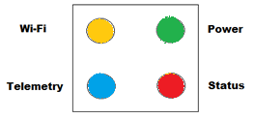 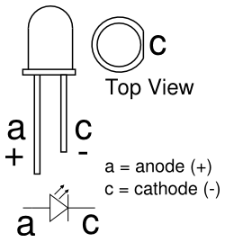

The LED assembly jig can help with positioning of the LED’s.

* The LED jig is intended to be remaining in position as part of the final build.
* The smaller part of the jig is a separator to ensure legs do not touch.
* LED should be flush against the flat side and orientated as above.

Example in the picture below.

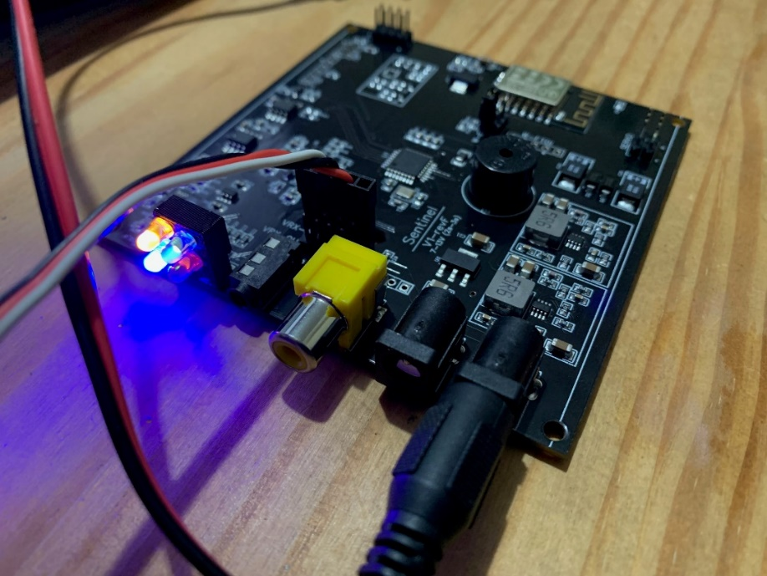

# AAT – DIY PCB connections – V1 rev F PCB

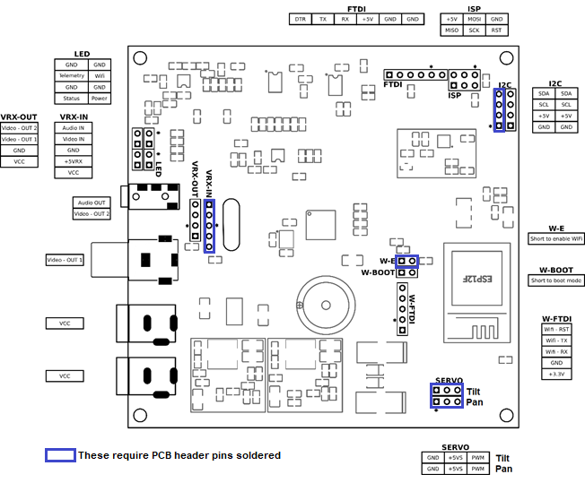

+5v vyyyyyyy

NOTE: “ * ” On the PCB diagram is GND pin.

NOTE: Square pins are pin number marking conventions only - ignore

**DANGER ZONE:**

* VRX-IN connector has both +5v and VCC (same as supply battery voltage input).
* Carefully check any wiring to VRX-IN.
* Ensure any RX powered by the PCB can support the chosen voltage.
* VRX-OUT connector has VCC (same as supply battery voltage input).

**SENTINEL AAT is 13V maximum supply – a 3S LiPo**

# AAT – DIY PCB connections – V1 rev E PCB

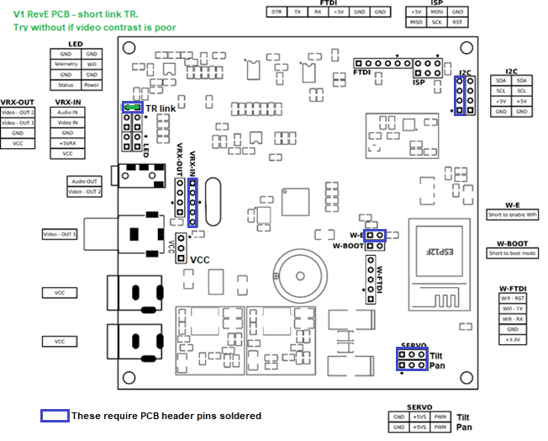

+5v vyyyyyy

y

NOTE: “ * ” On the PCB diagram is GND pin.

NOTE: Square pins are pin number marking conventions only - ignore

**NOTE: JUMPER “TR”** was added to V1 rev E boards (next to LED pins) to allow easier compatibility with video receivers that do not confirm fully to normal standards. Normally this should be closed / jumpered.

**DANGER ZONE:**

* VRX-IN connector has both +5v and VCC (same as supply battery voltage input).
* Carefully check any wiring to VRX-IN.
* Ensure any RX powered by the PCB can support the chosen voltage.
* VRX-OUT connector has VCC (same as supply battery voltage input).

**SENTINEL AAT is 13V maximum supply – a 3S LiPo**

# AAT – DIY PCB connections – V1 rev D PCB



+5v vyyyyyyy

NOTE: “ * ” On the PCB diagram is GND pin.

NOTE: Square pins are pin number marking conventions only - ignore

**DANGER ZONE:**

* VRX-IN connector has both +5v and VCC (same as supply battery voltage input).
* Carefully check any wiring to VRX-IN.
* Ensure any RX powered by the PCB can support the chosen voltage.
* VRX-OUT connector has VCC (same as supply battery voltage input).

**SENTINEL AAT is 13V maximum supply – a 3S LiPo**

# AAT – 3D STL and source files

Files are available here: <https://github.com/aat-sentinel/AAT-lite-hardware>

# AAT – 3D print recommendations

Print recommendations:

* Print with the highest % of material that you can as the AAT will need to be resilient enough to deal with handling during normal and potentially rough use.
* Figures below are recommended minimum for PLA / ABS.
* Adjust for your needs.
* TIP – for printing gears the most common fault is to avoid “elephants foot”. See guide: https://rigid.ink/pages/ultimate-troubleshooting-guide#issue-elephants-foot-15

|  |  |  |
| --- | --- | --- |
| Item | ABS/PLA | PET-G |
| QR adapter | 80% / 5 shells | 80% / 5 shells |
| Box - base | 35% / 5 shells | 55% / 5 shells |
| Gears | 35% / 5 shells | 55% / 5 shells |
| All other parts | 25% / 5 shells | 45% / 5 shells |

# AAT – 3D printed component preparation

Preparation:

1. Smooth edges of **Box – panel xxxx** to ensure a good fit in **Box – base**.
2. Check gears mesh together well by rotating **Gears – servo** and **Gears – main shaft** together. If required smooth teeth with a file or glass paper until a good mesh is achieved.
3. Fixing holes in the **Tilt – base** are printed horizontally and may benefit from clearing with a 2mm drill.
4. Servo holes in the **Tilt – mount plate** are printed horizontally and may benefit from clearing with a 2mm drill.
5. The bearing pivot hole in the **Tilt – mount plate** is printed horizontally and will benefit from clearing with a 3mm drill.
6. Smooth sharp edges as required. https://github.com/aat-sentinel/AAT-lite-hardware

# AAT – DIY Case assembly

Box assembly:

1. Attach **tripod mount (QR or threaded)**  to **Box – base** using M3 10mm self tapping screws.
2. Test fit to tripod before proceeding as QR adapters can vary. This is best time to resolve.
3. **WARNING!** If using threaded mount, check to make sure the tripod screw does not go through and touch / damage PCB.
4. OPTIONAL OLED display - fit OLED into **Box – panel front** using **OLED - housing.** WARNING! :Tighten OLED M3 10mm screws until OLED is just touching the front panel. Do not over tighten as OLED displays are very fragile. The glass will break even if gentle pressure is applied in the wrong places. Make sure it fits correctly into mounting position before tightening screws. The unit can be used without OLED fitted.
5. Fit **Box – panels front** to the PCB and place into **Box – base.** Fix PCB to **Box – base** using M3 10mm self tapping screws.
6. If using an OLED display, attach 4 wires from OLED to PCB I2C connector. Take note to ensure correct pins are connected at each end.
7. Note PCB is not rectangular. Side panels are very slightly longer.

Gear assembly:

1. Press fit 2 * bearings into **Box – top.**
2. Attach **Bearing retainer – outer** to **Box – top** using M3 10mm self tapping screws.
3. Test fit to tripod before proceeding as QR adapters can vary.
4. Trim servo mount point for flush fit. Rubber mounts not required.
5. Attach servo to **Box – top** using M3 18mm bolts and M3 nuts. Servo should be able to move with a little force to allow adjustment later. Fit servo from underside.
6. Fit **Gears – servo** to servo circular or quad horn using M2 10mm screws from servo pack. See video for orientation of horn / screws. (recess face downwards with horn fitted inside recess). Trim screws.
7. Attach servo horn / gear assembly to servo.
8. Power up servo and ensure it is set to center using FC, RX, servo tester etc.
9. Fit **Gears – main shaft** into Box-top bearings. Place so that one of the holes faces to an edge.
10. Attach **Bearing retainer – inner** to **Gears – main shaft** using M3 10mm self tapping screws.
11. Push **Gears – servo** towards **Gears – main shaft** with very gentle pressure to minimise any gear movement and tighten servo bolts.
12. Attach **Box – gear cover** to **Box – top** using M3 10mm self tapping screws.

Tilt assembly:

1. Press fit bearing into one of **Tilt – arms**.
2. Fit servo horn to inside of **Tilt – arms** using M2 10mm self tapping screws. Excess may bet cut /files smooth
3. Fit **Tilt – arms** to **Tilt – base** using M3 10mm self tapping screws.
4. Fit tilt servo to **Tilt – mount plate** using M3 10mm self tapping screws and with the servo spline positioned in centre of plate.
5. Fit tilt servo to **Tilt – mount plate** to **Tilt – arms** using M3 16mm bolt and nut. Use washer under nut and between Tilt – mount plate and Tilt – arms. Do not over tighten. Plate should move freely.
6. Power up servo and ensure it is set to center using FC, RX, servo tester etc.
7. Servo spline can be placed into servo horn with mount plate at approx. 45-degree angle. This is starting point for future calibration. Servo horn retaining screw can be fitted – or after tilt calibration.
8. Attach **Tilt – base** to **Gears – main shaft** using M3 10mm self tapping screws.

Final assembly:

1. Prepare cables used to connect the AAT PCB to the receiver. ***Take utmost care*** to check the polarity of cables and connections to avoid the magic smoke that powers all electronics. Servo wires are ideal and are included for this. Pins can be swapped to make the correct cable similar to this video link https://www.youtube.com/watch?v=rR6aX_8v3pM
2. Wind tilt servo cable around a pen to produce a helical cable – greatly improves endurance and performance of cables during pan actions.
3. Similarly, wind a video connection cable.
4. Feed both servo and video connection cables through the **Tilt – base** in preparation for connecting to the PCB.
5. Insert **Box – panels side** and **Box – panels rear** into **Box – base**.
6. Position the assembled tilt unit above the box and connect servo and video cables to the AAT PCB.
7. Lower the tilt unit onto the box, noting the arrows on the components showing the correct orientation of the top assembly in relation to the lower assembly and fit using M3 16mm self tapping screws.

# AAT – Assembled unit



# AAT – internal views

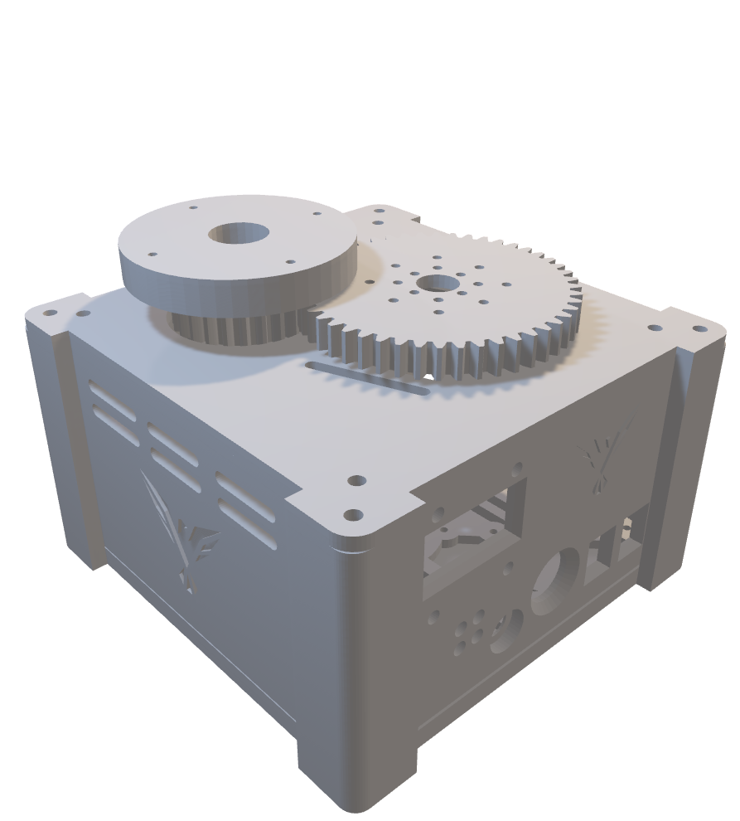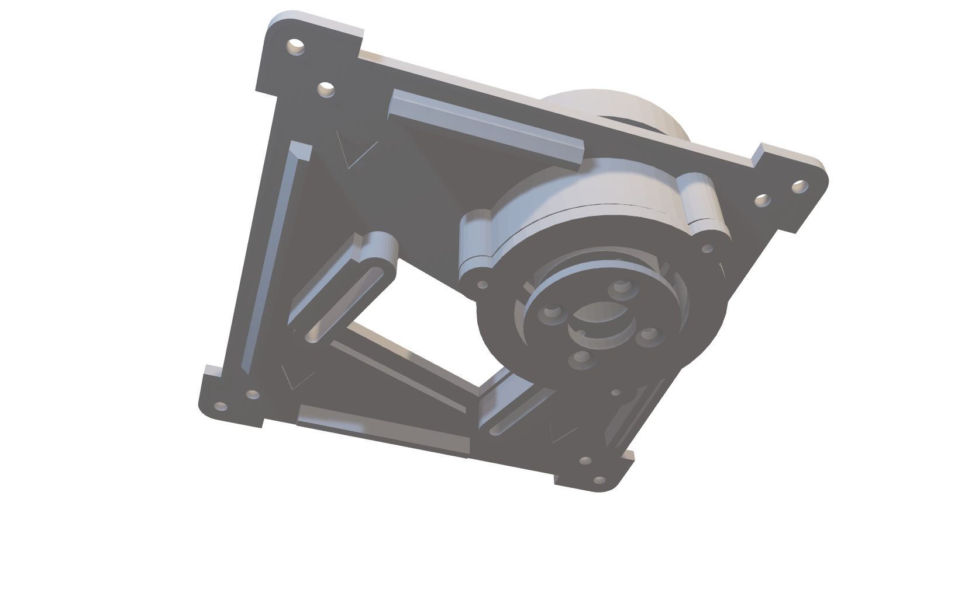

# Parts list – STL components

|  |  |
| --- | --- |
| Box - base | Tripod mount - QR adapter or threaded |

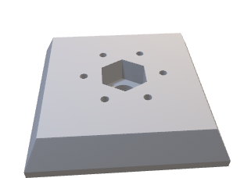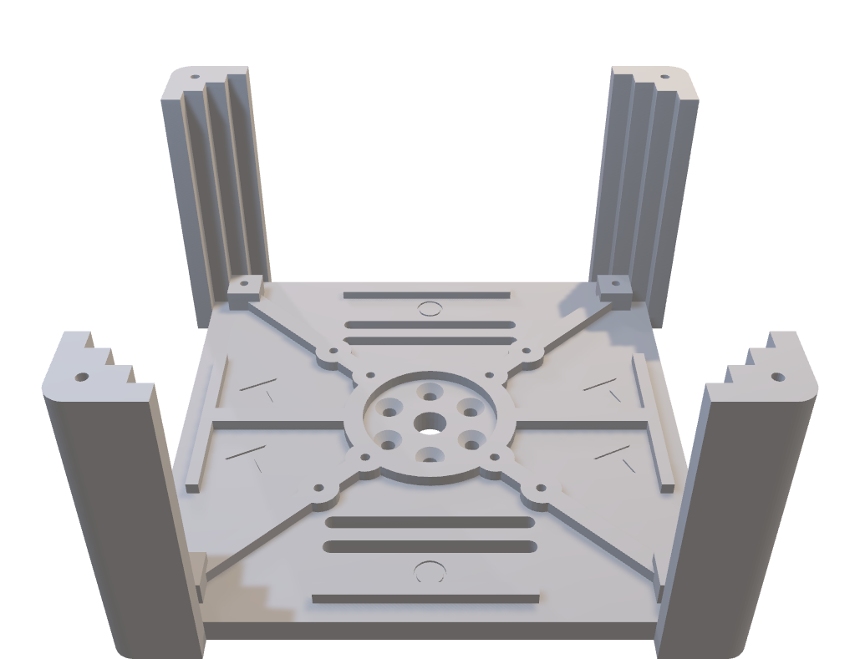

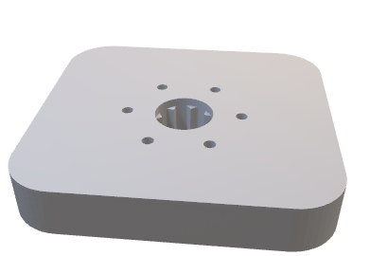 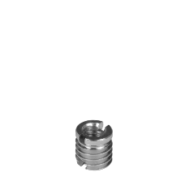

|  |  |
| --- | --- |
| Box – panels side | Box – panels front with OLED and rear |

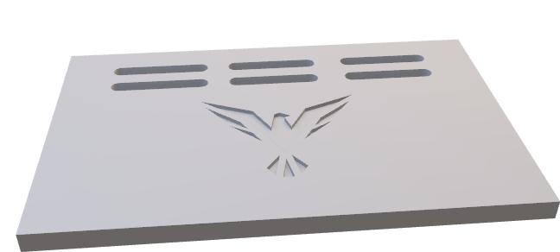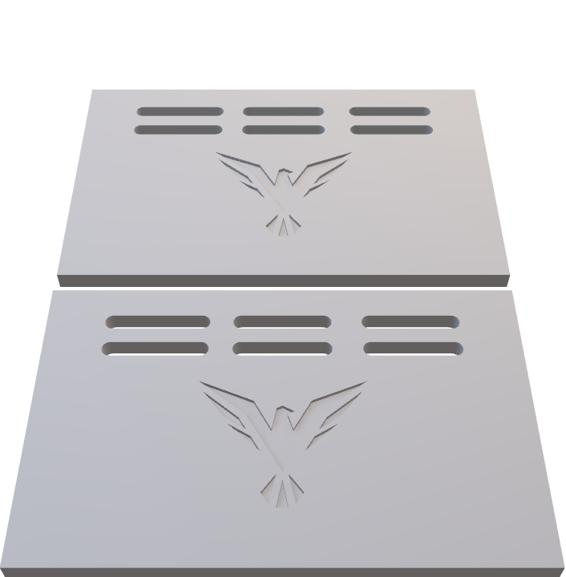

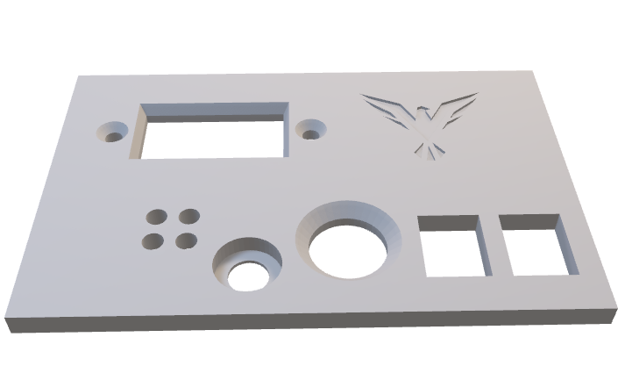

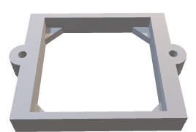

|  |  |
| --- | --- |
| Box – top | Box – gear cover |



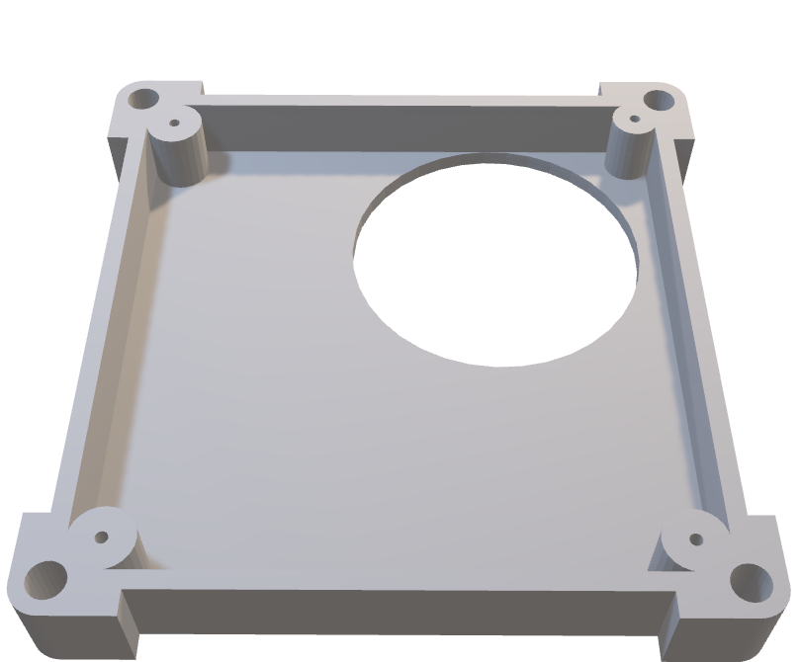

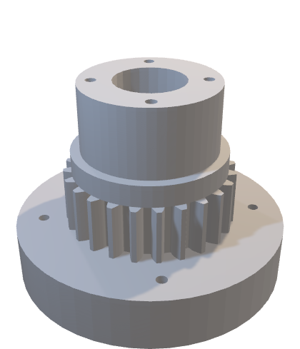

|  |  |
| --- | --- |
| Gears – main shaft | Gears - servo |



|  |  |
| --- | --- |
| Bearing retainer - inner | Bearing retainer - outer |



|  |  |
| --- | --- |
| Tilt - base | Tilt - arms |

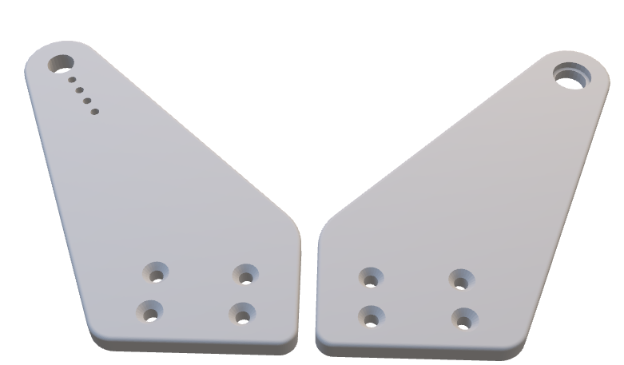

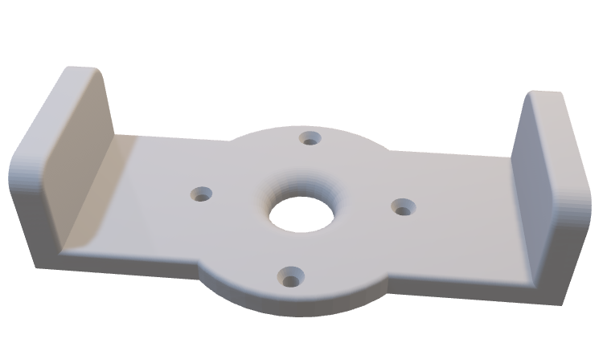

|  |  |
| --- | --- |
| Tilt – mount plate | LED assembly jig |

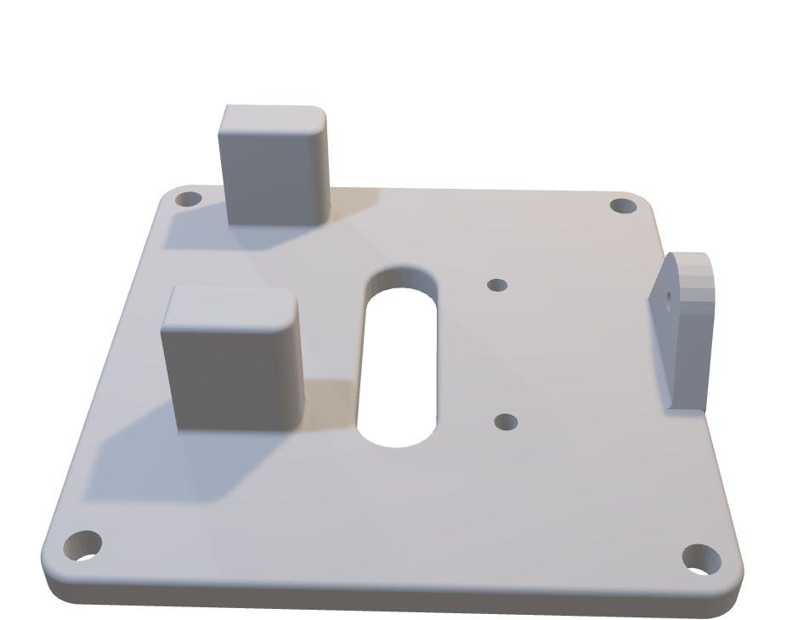

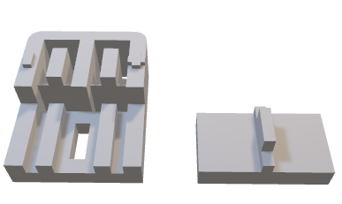

# Parts list – optional AAT STL extras

|  |  |
| --- | --- |
| 4 “ LCD side panel mount |  |

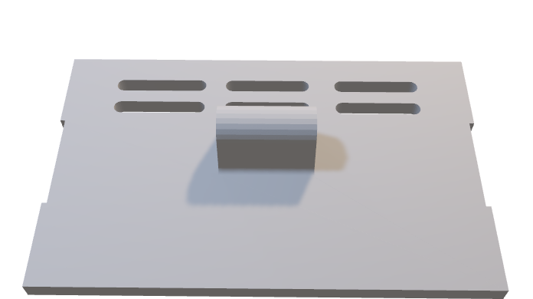

|  |  |
| --- | --- |
| Battery side panel battery mount |  |

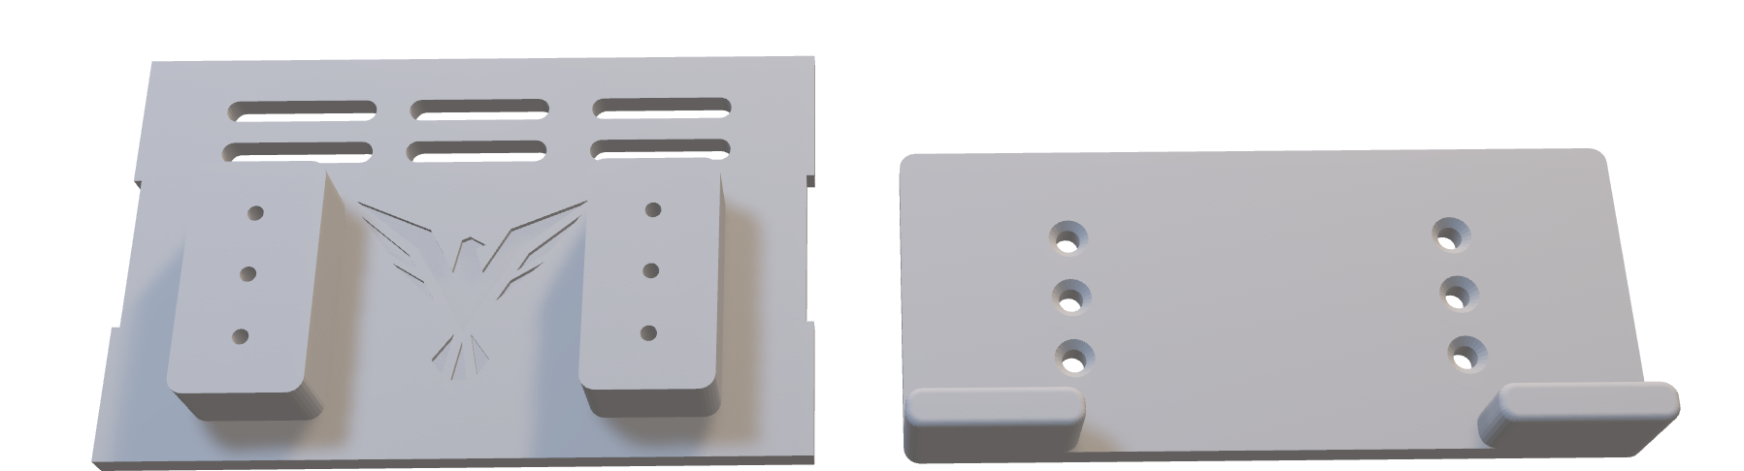

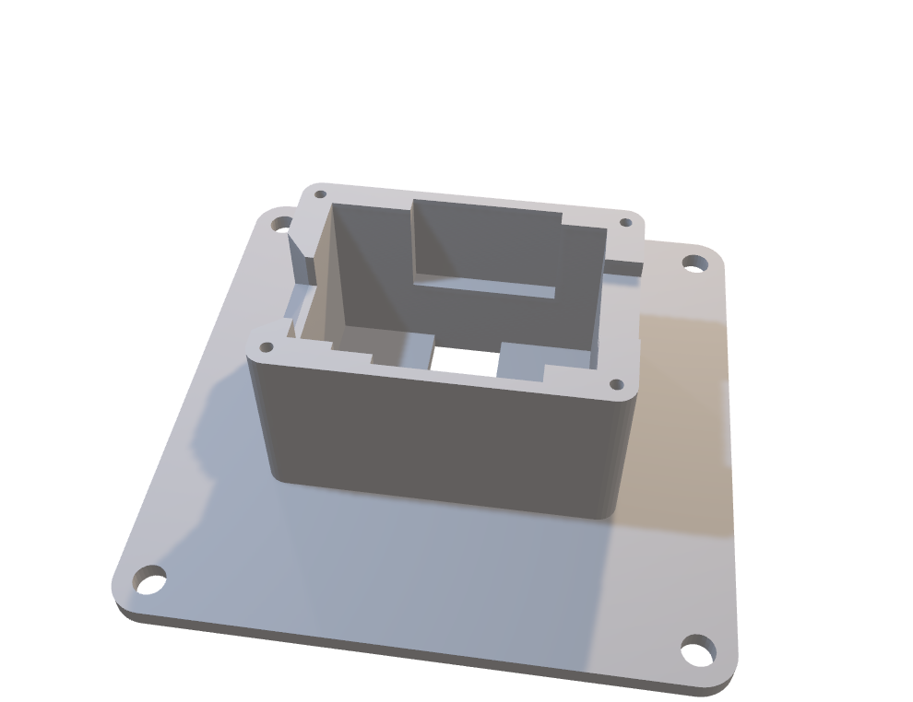

|  |  |
| --- | --- |
| EACHINE RX5808 pro mount |  |



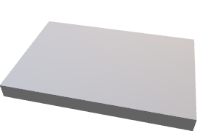

|  |  |
| --- | --- |
| Alternative XT60 switched panel mount    ImmersionRC Powerplay panel mount |  |

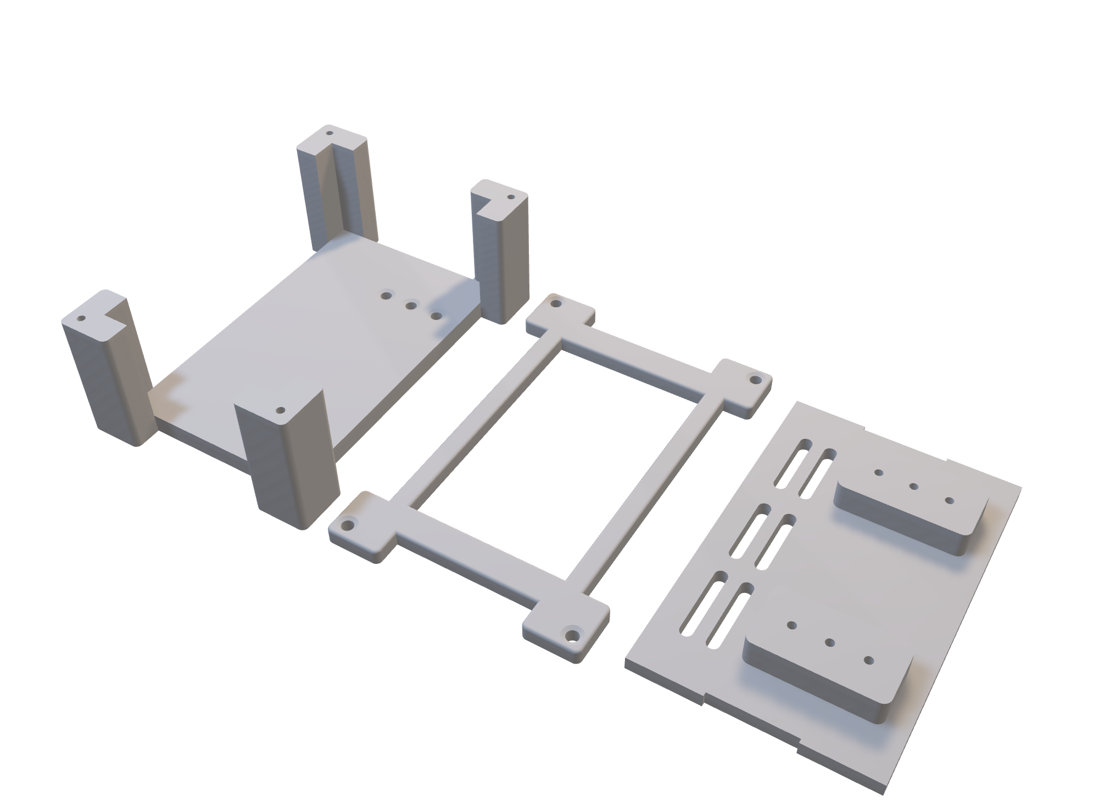

# Parts list – miscellaneous STL

|  |  |
| --- | --- |
| Tripod leg battery mount | XT60 in line power switch |

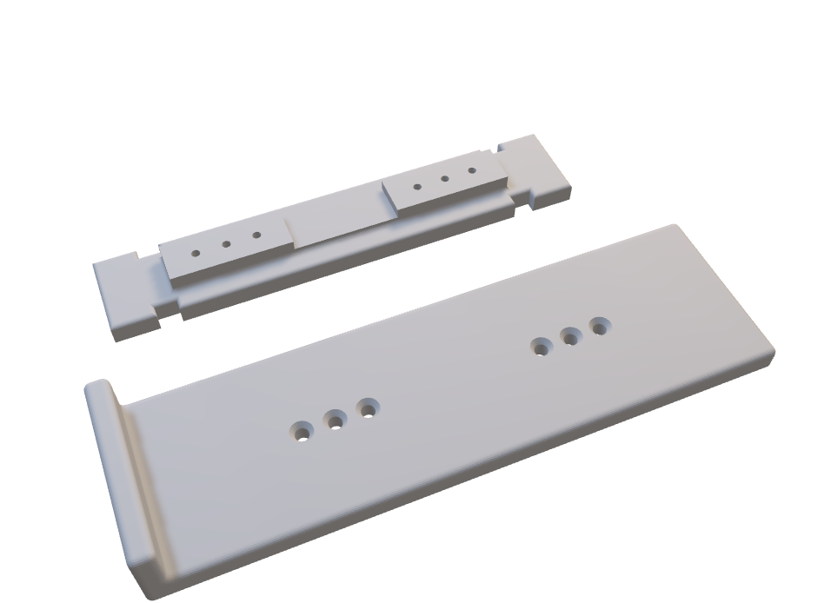

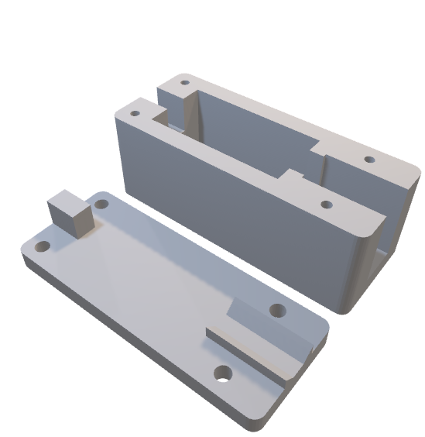

|  |  |
| --- | --- |
| Tripod leg GoPro mount | XT60M to XT60F in line power switch |

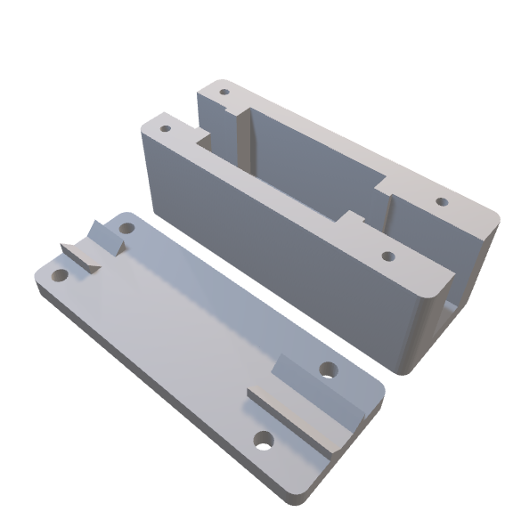

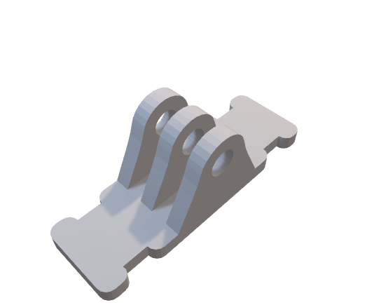

|  |
| --- |
| Tripod leg 7” LCD mount |

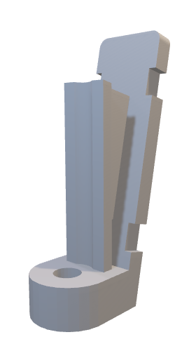

# Parts list – fixings

|  |  |
| --- | --- |
| **Item** | **QTY** |
| 6805 2RS bearing | 2 |
| F693ZZ bearing | 1 |
| M3 16mm ST screw | 4 |
| M3 10mm ST screw | 37 |
| M2 10mm ST screw | 6 |
| M3 bolt 18mm | 5 |
| M3 Washer | 2 |
| M3 Nut | 5 |
| OLED screw (use M3 10 ST screw) | 2 |
| 2 * MG996R 180 | 2 |
| 1 * ¼ - 20 camera mount thread insert | 1 |

# Parts list – components

|  |  |
| --- | --- |
| **Item** | **QTY** |
| RCA / Phone / CINCH | 1 |
| 4 Pole 3.5mm | 1 |
| LED | 4 |
| OLED | 1 |
| Buzzer | 1 |
| PCB header pin header strip - 40 pins | 1 |
| Jumper | 1 |

# Parts list – extras

|  |  |
| --- | --- |
| Servo lead (RX internal) 150mm M2M | 1 |
| Servo lead (RX external) 100 M2F | 1 |
| Goggles video cable - 4 pole fatshark style 3m | 1 |
| XT60-DC 5.5/2.1 Power leads | 1 |
| OLED wires | 4 |

# Video RX connections

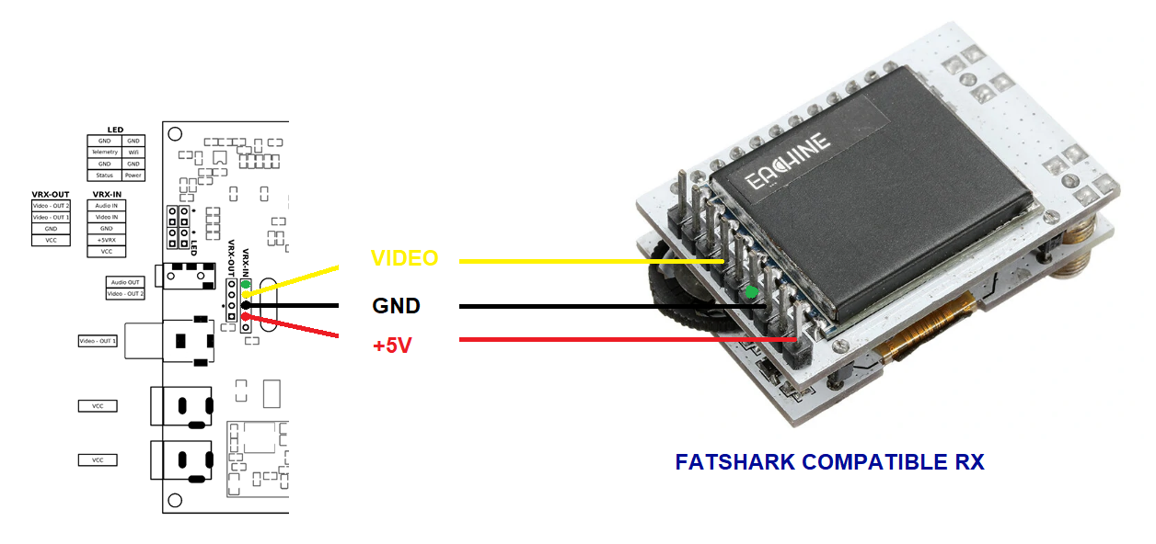

***Take utmost care*** to check the polarity of cables and connections to avoid releasing the magic smoke that powers all electronics.

Servo wires are ideal and are included for this. Pins can be swapped to make the correct cable similar to this video link https://www.youtube.com/watch?v=rR6aX_8v3pM

# PCB versions

|  |  |
| --- | --- |
| 1 rev D | Initial release – green board |
| 1 rev E | Second release – black board  Added “TR” link to enable/disable 75R video terminating resistor for easier video compatibility  Added Vbat breakout pins  Improved silk screen user info |
| 1 rev F | Third release – black board  Remove TR link. Replaced with pcb track link for very rare times it is used  Improved silk screen user info |

# Document revisions

|  |  |
| --- | --- |
| 1.0 | Initial release |
| 1.1 | Added bold warning about 3S maximum  Added extra 3D STL options  Added camera mount thread insert option |
| 1.2 | Added pan / yaw connections  Added extra led connection info  Added LED jig STL  Added IRC PowerPlay STL |
| 1.3 | Added warning about mounting screw length  Added recommended LED colors  Added Fatshark RX pinout for reference |
| 1.4 | Added note re Video input jumper  Added PCB version info  Added PCB Rev E layout diagram |
| 1.5 | Added notes re servo mounting.  Improved servo gear assembly wording.  Corrected servo orientation in image |
| 1.6 | Corrected missing I2C highlighted box on PCB header recommendations |
| 1.7 | Added PCB rev F layout diagram |
| 1.8 | Amended for changes in OLED mount |
| 1.9 | Improved LED JIG info |